Milkweeds For Monarchs

It is the time of year again when we start collecting milkweed pods full of ripe seeds to plant. The resulting milkweed plants will help the Monarch Butterflies and other species of pollinators survive next year. By planting and protecting Milkweed Stands along the Monarch migration route, we hope to conserve Monarch habitat and halt their recent decline in numbers. Monarch butterfly larvae feed exclusively on milkweeds and cannot survive without them. Every year in the fall, monarch butterflies across the eastern U.S. and Canada begin a 3,000-mile-long journey down to wintering grounds in Mexico. In the spring, these same butterflies head back north, and delight us with their presence once again. However, this amazing journey would not be possible without milkweed, a group of plants critical to the survival of the monarch butterfly. As butterflies, monarchs can feed on the nectar of a variety of different flowering plants, but as caterpillars, monarchs are entirely dependent on the availability of milkweed.
Monarch caterpillars hatch from eggs laid on milkweed plants and feed on the leaves of the plant as they grow. If these plants are mowed, removed, or sprayed with pesticides or herbicides, the caterpillars will not survive. Protecting these plants, especially during the egg-laying period from July through September, helps both monarch butterflies and caterpillars continue their life cycle and ultimately results in more monarch butterflies that can complete their journey to Mexico and back.
In the past, milkweed was viewed as a toxic weed. Today, we know that milkweed is a very important group of native plants that helps support many species of wildlife, including monarch butterflies. Learn more about ways you can help ensure these beautiful butterflies are around for generations to come by visiting the Monarch Joint Venture.

Here is information from the Ohio Pollinator Habitat Initiative on how to collect and deliver the seeds. If you have any questions, you may contact Summit SWCD at 330-926-2452.

Ohio Pollinator Habitat Initiative Information from Marcy Lininger of US Fish & Wildlife Service:
“Hello OPHI Partners! I hope the summer is going well and you have been hard at work doing great things for monarchs, pollinators and other wildlife species! We hope you all plan to help with the Annual Pod Collection this year. The message we want to get out is to have citizens find potential common milkweed plants to harvest and monitor them starting Sept 1. As we all know, last year we received many green pods that contained non-viable seeds. So we want to stress that citizens start checking pods first and when they are ripe, then pick them and turn them in. Greenish-yellow or yellowish-brown pods can have mature seeds in them so the best advice is to have citizens wait until they turn yellowish brown and then start checking the inside of the pods. If the seeds are dark brown (not milky brown) then the pod is ready for harvesting. We will accept pods until Nov 1 (one-day buffer). We want to make sure citizens know that if it is after October 31st do not collect pods to bring to the collection bin. Residents can certainly collect for as long as they want to and we can provide the SWCDs with instructions to provide to citizens on how to stratify, dry and germinate seeds on their own.”

Here are also some helpful tips from Franklin Soil and Water Conservation District.
Let’s talk about Milkweed & Common Milkweed Harvesting Tips!
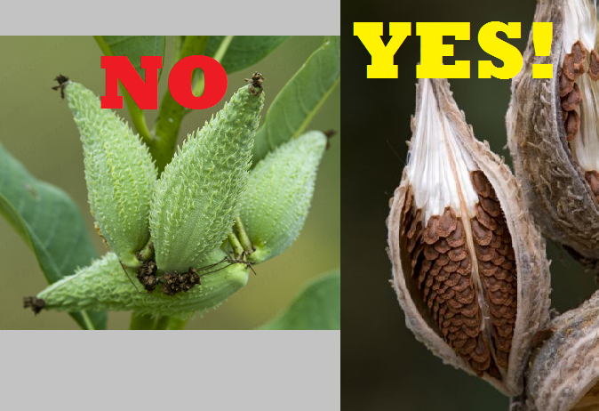

- If pods are bright green, they are not ripe or ready to be collected.
- Ready to pull pods will be gold/yellow or gray to brown in color.
- Don’t collect pods that are already open, as they might be infested with insects.
- Test the seams of the pod, if they easily “pop” open with gentle pressure they are ready.
- Freshly collected pods should be dried and kept in paper grocery bags (not plastic!).
We are only collecting pods from common milkweed, not butterflyweed, Indian hemp, swamp milkweed or related plants. It is recommended to wear disposable gloves when picking and handling pods.
More of a visual learner? Watch this milkweed collection video for help.
Harvesting seed pods from milkweed plants will not have any effect on the population of milkweed in established areas but remember to never collect seeds from the wild or natural areas unless you have permission!

The Milkweed seed-pod collection site in Summit County is at the Ohio State University Extension Office, located at 1100 Graham Road Circle, Stow, Ohio, 44224, close to the Route 8 exit.
